**Name:** V Venkata Sri Prasad

**Batch:** Data Engineering

**Date:** 16/02/2024 – (Day 22)

Topics:

1. ADLS
2. Creating Azure Data Lake Storage Gen2

**ADLS:**

The purpose of this project is to design a prototype in Axure for an Azure Data Lake Storage (ADLS) platform. The prototype will focus on showcasing key features and functionalities of ADLS, providing a simulated user experience for stakeholders to review and provide feedback.

Project Objectives:

Develop a high-fidelity prototype that demonstrates the core features of ADLS.

Provide stakeholders with a visual representation of ADLS functionalities.

Gather feedback from stakeholders to iterate on the prototype design.

**Data Lake Storage Gen2:**

Azure Data Lake Storage Gen2 refers to the current implementation of Azure's Data Lake Storage solution. The previous implementation, Azure Data Lake Storage Gen1 will be retired on February 29, 2024.

Unlike Data Lake Storage Gen1, Data Lake Storage Gen2 isn't a dedicated service or account type. Instead, it's implemented as a set of capabilities that you use with the Blob Storage service of your Azure Storage account. You can unlock these capabilities by enabling the hierarchical namespace setting.

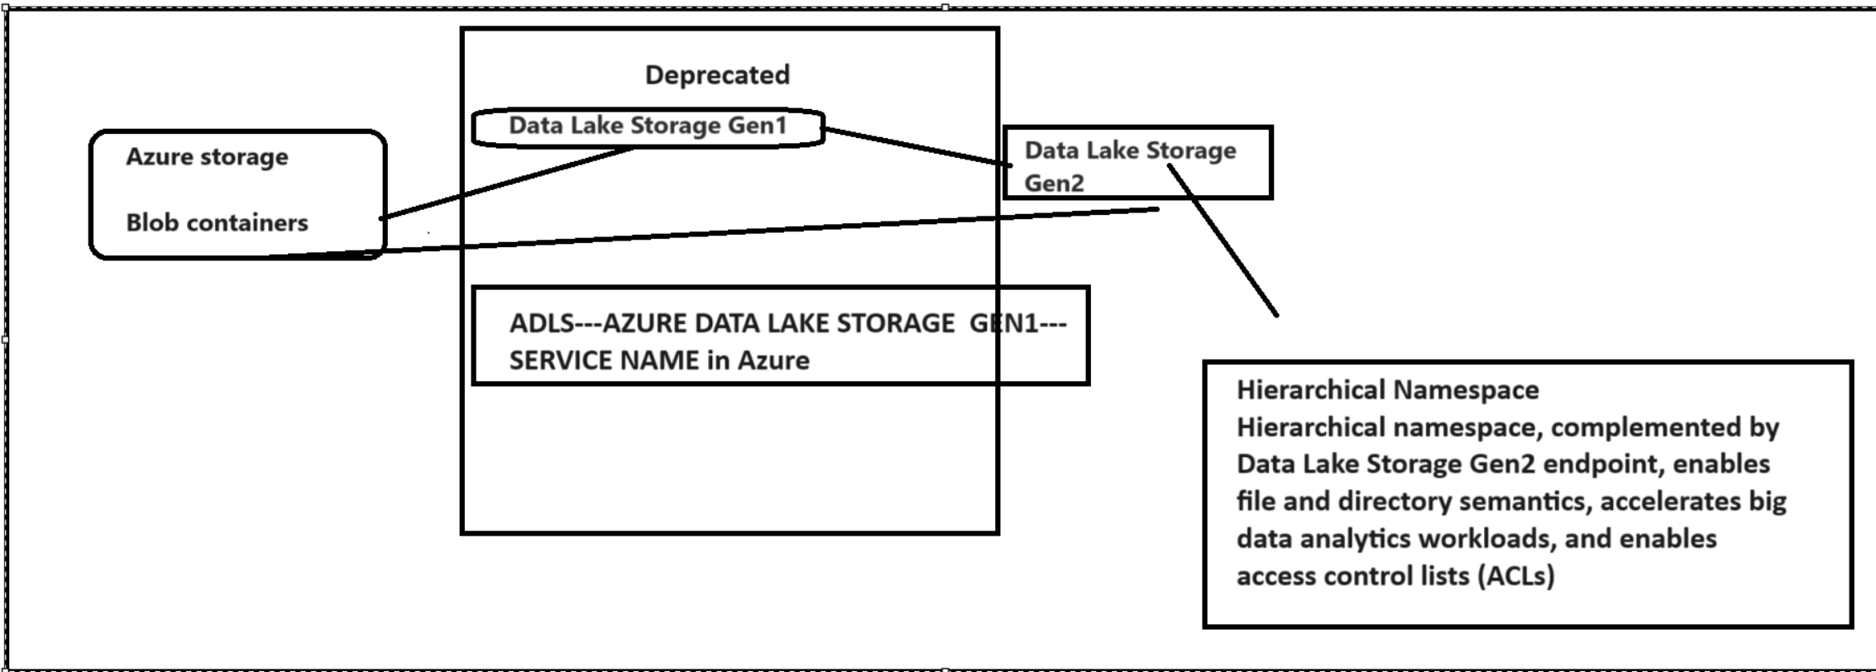

**Create a storage and enable hierarchical namespace:**

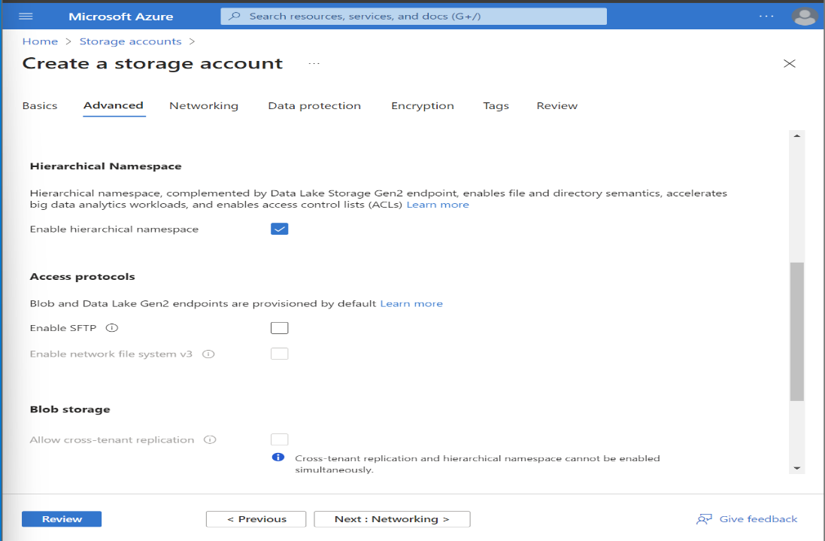

**Create a container:**

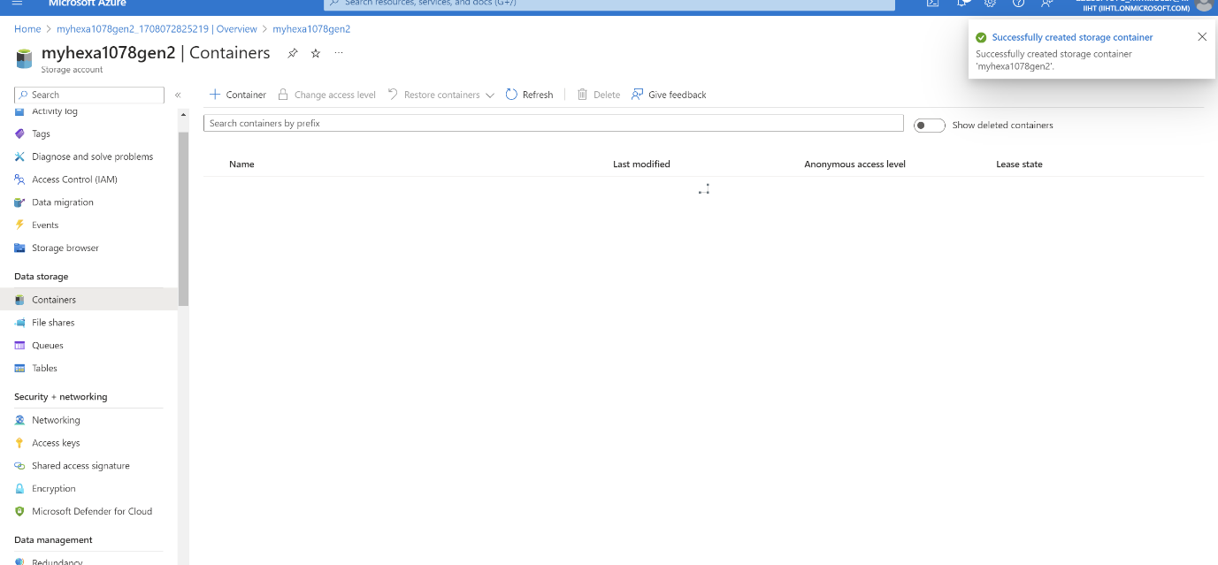

**After Creating Container select bob (anonymous read access for blobs only)**

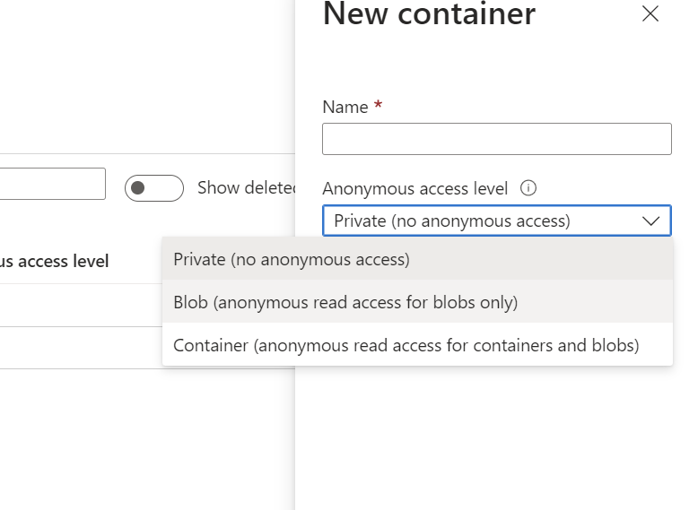

**Go to access keys:**

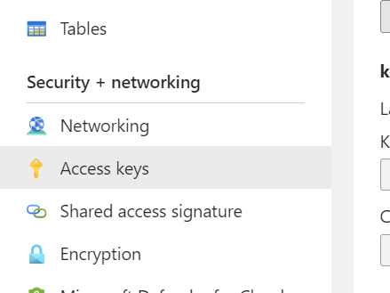

**Copy the connection string in key1:**

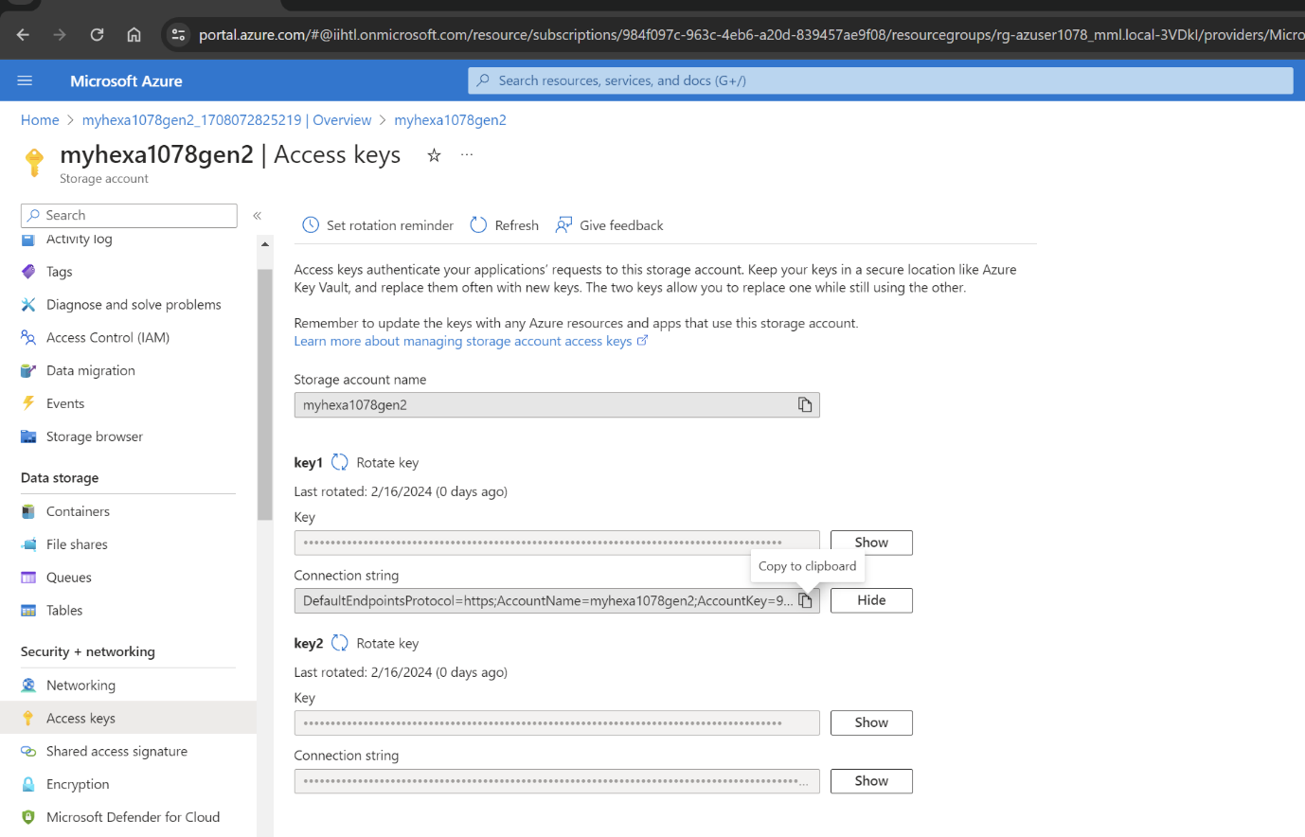

**Connect to Azure resources:**

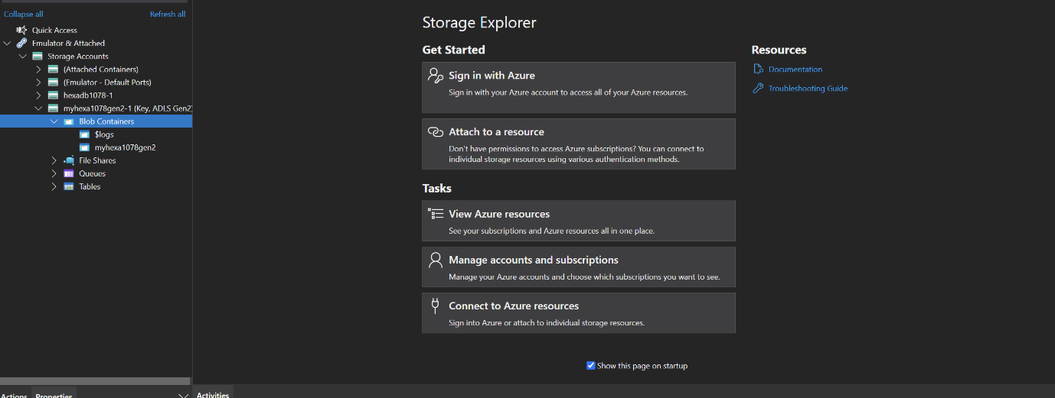

**Select Strong account or service:**

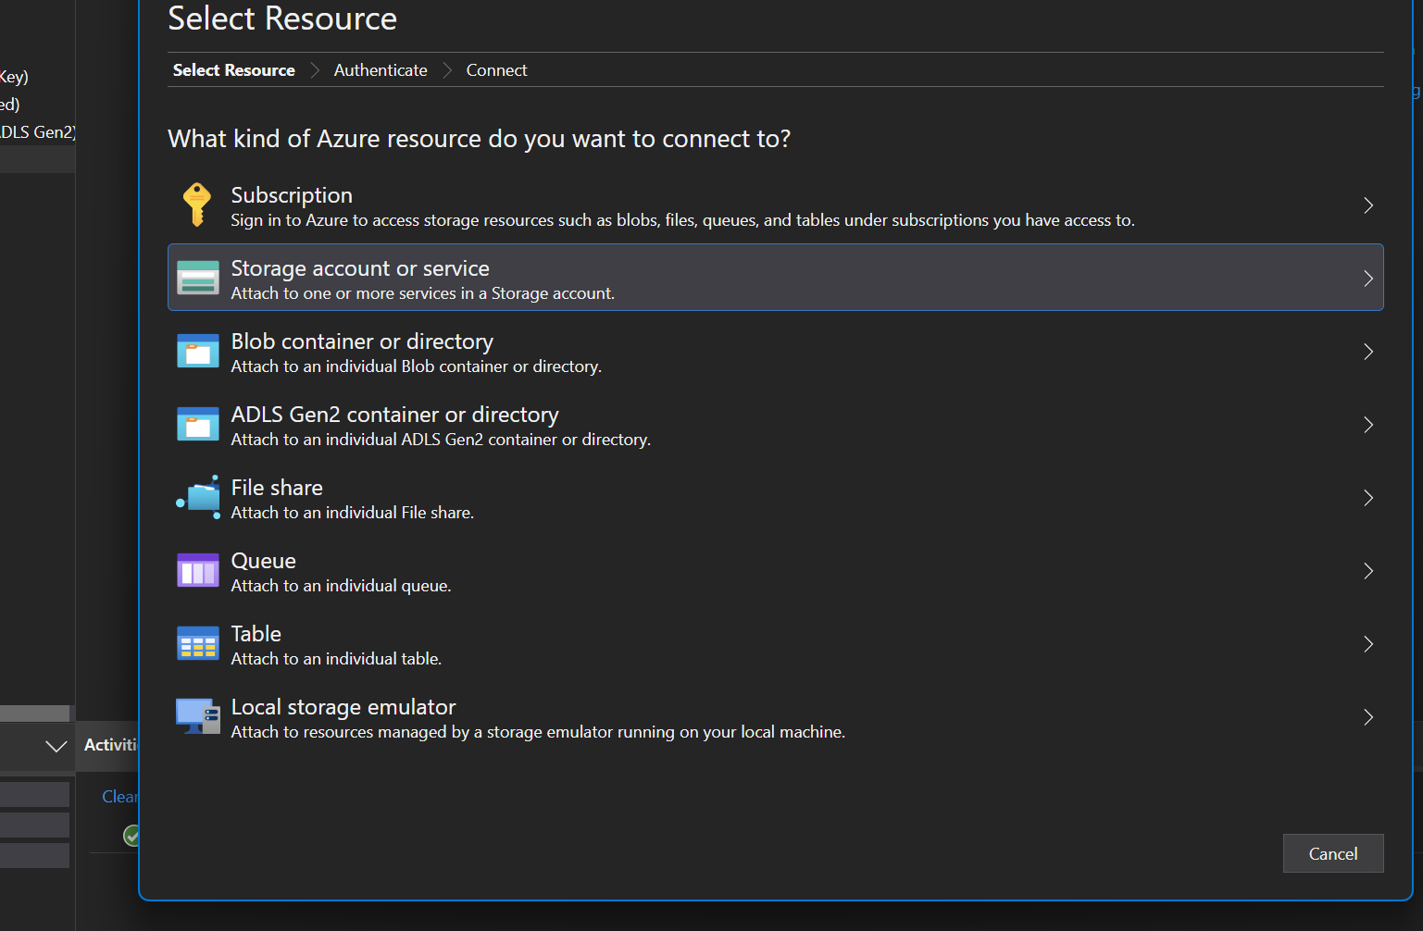

**Select Connection string (key or SAS) and paste the url:**

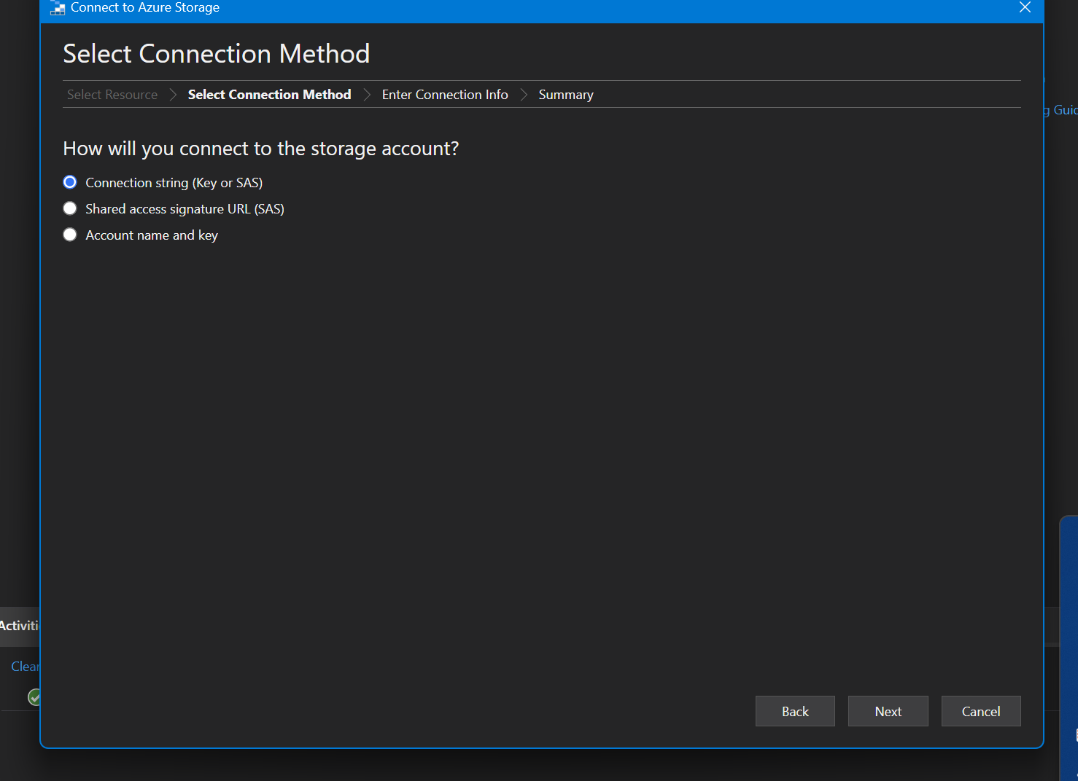

Hence the delta gen1

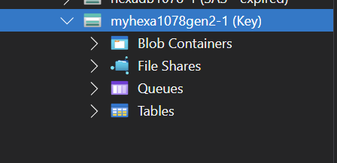

Notes: 